THE INTERNATIONAL COSMONAUT
A film by Maria Barnas
13.30 min, 2014

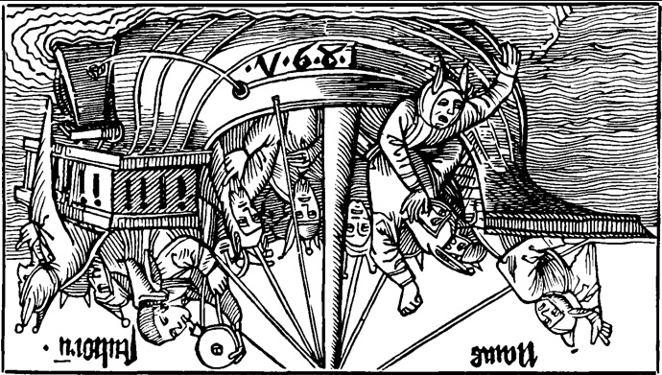

Good News: 'Wherever you are, wherever you may go, offer bread and salt to visitors, in accordance with timeless custom. Throw six twice but never thrice. Touch a chimney sweeper.'

Bad News: 'Rub the toe of a madman. All madmen. Any madman.'

The International Cosmonaut is based on a collection of rituals cosmonauts and travellers undertake worldwide, in preparation of their journeys, charming fate to safeguard their return.

Two computervoices (Good News and Bad News) represent the cast of this film that is entirely constructed out of 3 short video fragments found on internet.
The low-tech approach of this film, with its distorted and pixelated imagery, serves to show fading contours and dark patches of what man is able to manage - referring to struggles of fading political power and technical innovation in countries that have given up their space programmes. On another level, distortion is found in the psychological struggle of the traveller who has to set his own boundaries.
The question of who owns what images and what knowledge is threaded throughout the film. Ultimately, the traveller in his space capsule represents everyone that has landed in our age determined by individualism and the desire to escape.

An upbeat belief, the quest for knowledge and discovery is counterbalanced by a darkness in the human soul that allows for questions, hesitation and poetry.
A poetic essay, a philosophical animation, an empty vessel - The International Cosmonaut will launch you into areas yet to be discovered.

*

NOTE: The interior dialogue that comprises The International Cosmonaut is written by poet and visual artist Maria Barnas. Some fragments are based on Peter Sloterdijk's essay 'Cell-building, Egospheres, Self-Containers -The Explication of Co-Isolated Existence via the Apartment'.

